Frameworks are structured methods for organizing information, making complex ideas simple and actionable.
They fit under the storytelling umbrella but offer different approaches to simplify and engage your audience.
This guide explores various types of frameworks, how to create them, and when to use them effectively.

What Are Frameworks?
Frameworks simplify information into structured, actionable steps. They can take many forms:
- Conceptual Frameworks: Analogies or metaphors like the "YouTube Chain" or "Umbrella."
- Process-Oriented Frameworks: Step-by-step guides or acronyms like BENS.
- Visual Models: Diagrams, flowcharts, or ladders for easier comprehension.

When to Use Frameworks
Frameworks aren’t necessary for every video. Use them when:
- You’re explaining a complex idea.
- The framework can simplify or clarify information.
- You want to make something complex easy to remember
- It fits naturally into your content.

Types of Frameworks and How to Use Them

1. Acronyms
- What Are They?
Acronyms simplify concepts into a memorable word, where each letter represents a step or idea (e.g., BENS).
- How to Create One:
  - Break your idea into its core components.
  - Use the first letters to form a word or phrase.
  - Adjust wording to make the acronym easy to remember.
- Example:
Teaching productivity with "TITS":
  - T: Time Block.
  - I: Ignore Distractions.
  - T: Two-Hour Work Sprint.
  - S: Short Breaks.
- Pro Tip: Use AI to help generate acronyms based on your components.
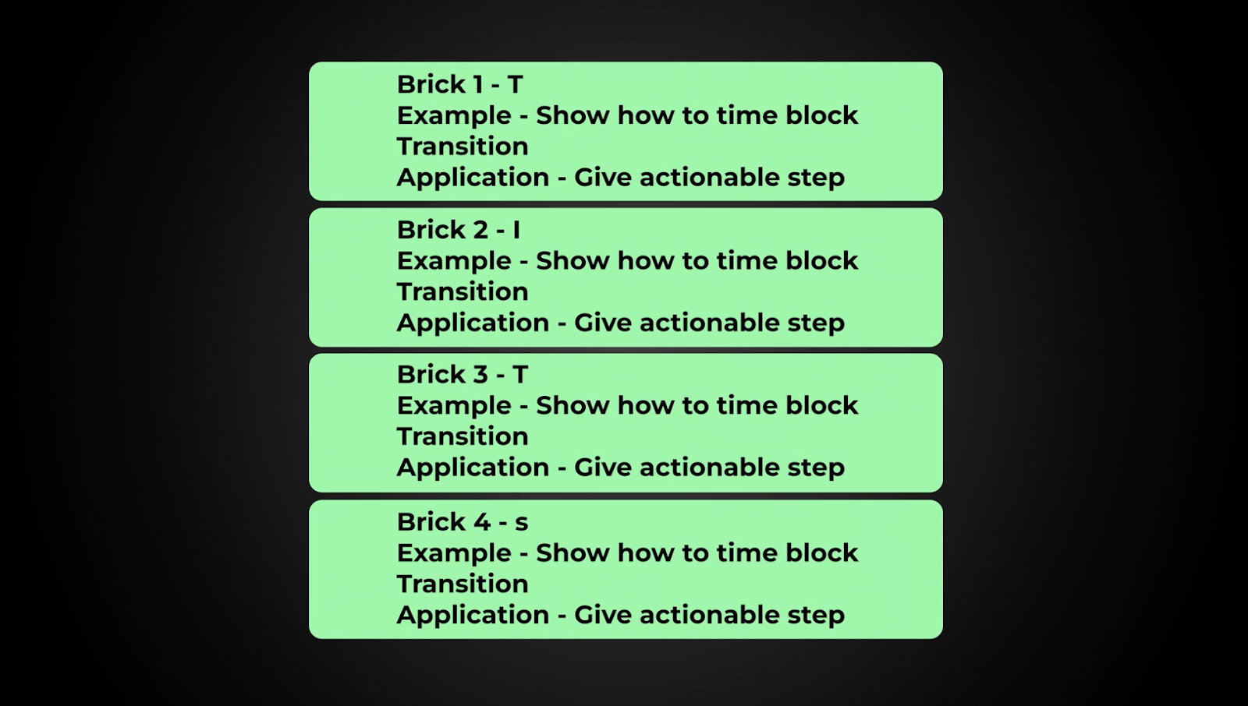
You could make each point of your video a letter then stick to the Example/Application structure for each one OR just use it as one point in your video.

2. Conceptual Frameworks
- What Are They?
Analogies or metaphors that visually explain a concept, like an umbrella for overarching ideas or a ladder for progress.
- How to Create One:
  - Identify the concept you want to simplify.
  - Compare it to something familiar that shares similar characteristics.
  - Design the framework (e.g., a tree for branching ideas).
- Examples:
  - A sales funnel for customer journeys.
  - A target for goal-setting.
- Pro Tip: These are memorable but can be challenging to create. Use them sparingly for big, complex concepts.

3. Processes
- What Are They?
Simple step-by-step guides that break down how to achieve a result.
- How to Create One:
  - Write down all the steps needed to achieve a goal.
  - Remove unnecessary steps, leaving only critical actions.
  - Present it visually or verbally in a clear, logical order.
- Examples:
  - A process for growing on YouTube: Research, Script, Shoot, Edit, Publish.
  - A checklist for effective thumbnails: Contrast, Clarity, Curiosity.
- Pro Tip: Processes are common, effective, and ideal for tutorials.

How to Decide Which Framework to Use
- Ask yourself:
  - Does this information need simplification?
  - Will a framework make the concept clearer or more memorable?
  - What style resonates with my audience?

Mistakes to Avoid with Frameworks
- Forcing a Framework: Only use one if it enhances the content.
- Overcomplicating: Frameworks should simplify, not add confusion.
- Copying Others: Adapt frameworks to your unique style and audience.

Using Frameworks with Examples
Frameworks can act as:
- A Single Point: Use it to explain one idea in the video.
- A Full Structure: Base your entire video around the framework, with examples for each section.

Adjusting Creativity to Your Audience
Not all audiences appreciate quirky or creative frameworks. For example:
- Ed’s Style: Over-the-top metaphors, humor, and sketches work for creators seeking inspiration.
- Your Style: May require straightforward explanations, clean visuals, and practical steps.
Use ready-fire-aim to test what resonates with your audience. Avoid replicating someone else’s style—focus on what works for your viewers.

